**Take input of expression as string. Use stack to check if the expression has valid/invalid parenthesis.**

**Example-1:**

**Input:** 5 + ((2*3) + 4)

**Output:** Expression has Valid Parenthesis.

**Example-2:**

**Input:** 5 + ((2 * 3) + 4

**Output:** Expression has Invalid Parenthesis.

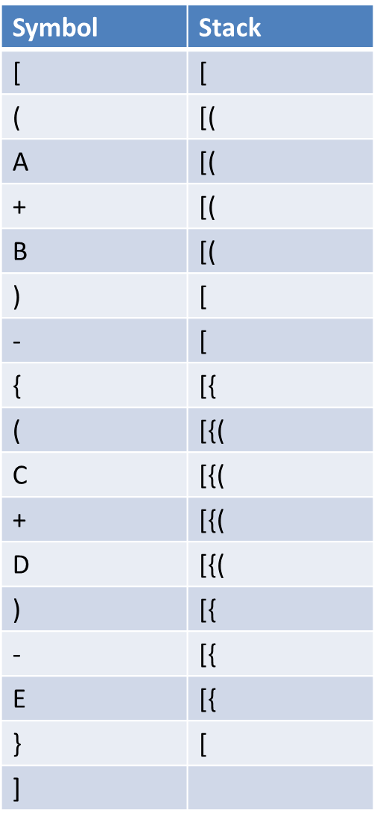Sample Simulation:   
[(A+B)-{(C+D)-E}]